Qi 0
•

'O
Qi

'O
Qi
Qi 0

0

Qi

0 Qi Qi 0

8th

"CJ

0,_
ITS
Department
City of
"
Bloomington
IIJ
I

0 Qi

'O
Qi
•
0 'Cl 'Cl •
D

I

0
Qi 'O
'O

0 Qi
Qi Qi
'o 'O
'o 0
'O 'O
Qi 'O •
Qi 0 'O •

Qi Qi
0 Qi
<b Qi ®ill!" -etl
'Cl ffiarn il'I

t
:\§
0 

0 0

'O

Qi

ll.lt
I

1th
Q •
•
0 0
0 Q

2025 Pedestrian Season
Outdoor Dining Program (Kirkwood Conversion + Parklets)

0 C: Qi
0
Qi i:

0
0 0 0

D 0

Q
g Qi
Qi Q Q
0
JU Parking

JU Parking

g 'Cl I 8 0
•
Qi
- 0 0 Qi
'O 0 Qi D Qi Qi o• ea co <oco o Qi 'O <o Qi 'O CD (D 0 co co m CD CD 0) 0 'o Qi <o 0
6th
0
-
co • •
After Hours
After Hours

•

Qi Q Qi 0 0 •

- co QJ ,o O 0 OQ,<zi <QC9

<o o<oQ>Qic
Ql Cl) • .----r-7:•CD 0 0 (D 'o 'Cl Qi 0 Qi o@
'o 'o co 'D 'O 'Cl

co 0
0
• •
Qi
<o 'O Qi Qi ••• • 0

el
'O 'O -

Metalworks •

€itn anGI ₀
o l!Ji!f0lrn

IU Parking

Qi <o 0 6 e
6 Q
Qi Qi Parl<im Lot
C(c)
After Hours
@ 0

Qi
Qi Q) 6 e .j;,J Q,
ro.s1

IIJ

0 OI g Monroe g :J
01 C: Q...,
C C:

-Q) County C
C 0 C:
e
·-
Vl C:
O...!.l Monroe County
lD
C IIJ

10 6
Orbit Room
l!) g
e
Courthouse e
..c
I:.) IE
:l "'O

6
Q, g
Q
Crazy Horse 0
⁰ <o
Q 0 Q:, Qi
-
•
Q,

'Cl Qi
0
•
@ •
Public Library g

0

'O
C
0 Re0ples Rarrl<.

0
-
'O co Qi 'O Qi Qi Qi 'O Qi'o 'Cl
•
0 0 0 •
'Cl 0 0 <o

irkwood

0 0 Qi
Q, Qi Qi 'Cl 'O 'o • •o 'O 'O Qi <oQJ
I 0 0
I
<o Qi
-0 Qi 0 'D Qi
•
• @ •
0 el <o
®
0

<o
-
•
0
Map Legend Road Closure Streatery
Meter
- Accessible Meter
@ New Accessible Meter
- Loading Zone
n New Load in Zone
.I
.j..J
C
Q)
0 0 Qi Qi

0

lD 0 0

<o

'O
{> 4traand 0

Washiro t®n ⁰
91• jaral<im@!Lot&) 6 Qi
•

IU Parking After Hours
Buffalouiel

Qi

- Qi 0 - 0

Qi 0
4tma1n1d Dunnn Par im@l10t
0

Qi @

<o Qi Qi

4th
0 0 0 •
  - • 0 Qi Qi 0 Qi 0

[() 0 Qi Ql

0

•
Qi 0 0 0 0 • 0
Bloomington Fire Station 1 (HQ)
•
0 0
0
Qi
0 125 250

Feet
(Scale of 1Inch Equals 250 Feet is valid only when printed at □rigin::il 36 x 2L inch size.)


a
0 0

i l l

l ..:3rd r + . 0
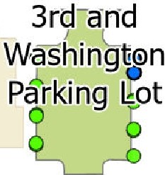
Po1ice Department
This map was produced by the City of Bloomington GIS, for use by the Ci,:yand general publiccis rrap iriforma ion. Ttie planimetricinformation is based on aerial orthoimag@rJ Aown in 2:)21.

The Corpora:ior,boundar; reflects anna::ationtsfeci1;e as of the print date 011 this
map,
Produced: 3/28/2025
Layout: Bloomi ngtonCityMap_36x24Landscape Project: ParkletsKirkwoodClosure

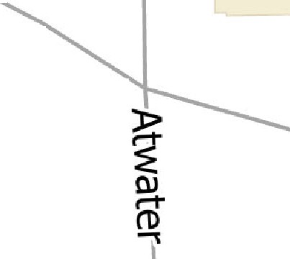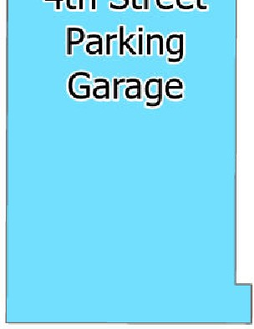Headquarters I

0
C
::,
::,

