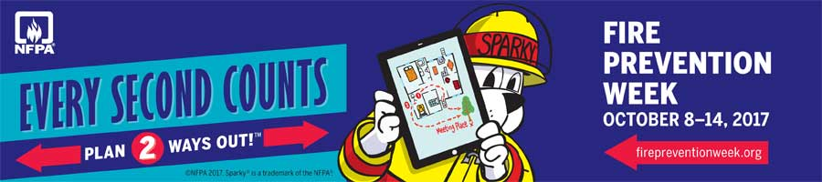

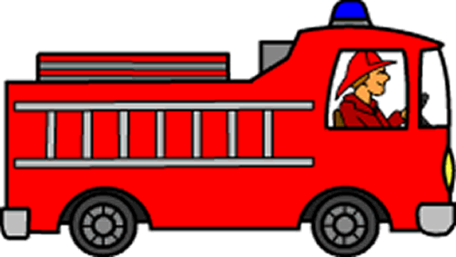
FIRE PREVENTION EXPO
SATURDAY OCTOBER 14TH
11 A.M - 4 P.M.
REVERE'S SERVICE STATION
CORNER OF 37 AND 158
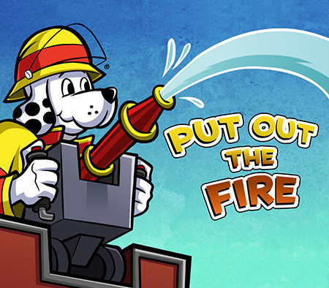



FREE GAMES
